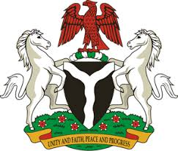
Please check against delivery
HUMAN RIGHTS COUNCIL
40TH SESSION OF THE WORKING GROUP OF THE UPR
REVIEW OF ZIMBABWE
26TH JANUARY, 2022

STATEMENT BY NIGERIA
Mr President,
Nigeria warmly welcomes the delegation of the Republic of Zimbabwe to the presentation of its Third National Report and appreciates the comprehensive update received from Zimbabwe today. We applaud the Government of Zimbabwe for its continued cooperation with human rights mechanism and the commendable efforts to implement previous recommendations.
2. We further commend the demonstrable commitment of the Government of Zimbabwe to improve the socio-economic well-being of its people; in particular, the National Development Strategy launched by the Government in 2018, to ensure the empowerment and prosperity of the people of Zimbabwe.
3. In the spirit of constructive dialogue, Nigeria wishes to recommend to the Government of Zimbabwe the need to:
- Strengthen efforts to mobilise resources and seek necessary international support to improve the socio-economic development of its people; and
- Ratify outstanding Treaties, Conventions and Agreements.
4. In conclusion, we wish Zimbabwe a very successful review process.
I thank you Mr President.
******

