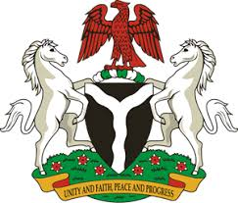

*Please check against delivery*

HUMAN RIGHTS COUNCIL

40TH SESSION OF THE WORKING GROUP OF THE UPR

REVIEW OF UGANDA

27TH JANUARY, 2022

**STATEMENT BY NIGERIA**

**Mr President**,

Nigeria warmly welcomes the delegation of the Republic of Uganda to the presentation of its National Report and commends the Government for its continued engagements with human rights mechanisms and commitment to the implementation of previous recommendations.

2. We take positive note of the laudable efforts and firm resolve of the Government of Uganda to promote the economic and social development of its people, particularly through the achievement of Sustainable Development Goals 8, 9,10, 13, 14 and 15.

3. In the spirit of constructive engagement, Nigeria wishes to recommend for consideration by the Government of Uganda as follows:

1. To ensure the promotion and protection of human rights, particularly women, children and persons with disabilities; and
2. To scale up efforts to improve the socio-economic well-being of its people and seek necessary support as appropriate.

4. In conclusion, we wish Nigeria wishes Uganda a very successful review process.

I thank you Mr President.

******