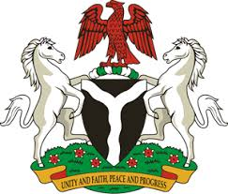
Please check against delivery
HUMAN RIGHTS COUNCIL
40TH SESSION OF THE WORKING GROUP OF THE UPR
REVIEW OF THE REPUBLIC OF TOGO
24TH JANUARY, 2022
STATEMENT BY NIGERIA
Mr President,
Nigeria warmly welcomes the delegation of the Republic of Togo to the presentation of its National Report for the Third Cycle UPR and commends the Government for its commitment to the promotion and protection of human rights, as well as its continued cooperation with international and regional human rights mechanisms.
2. Nigeria notes, with delight, the ratification of a number of international instruments by the Government of Togo, and its demonstrable efforts to further strengthen its legal and institutional frameworks to enhance the promotion and protection of human rights. The country’s strides in poverty alleviation and addressing the plight of the vulnerable groups are also commendable.
3. While acknowledging the achievements of Togo in the field of human rights, Nigeria wishes to recommend the need to:
- Sustain its efforts in poverty alleviation and addressing the plight of vulnerable groups in the society; and
- Continue to mobilise resources and seek necessary international support for the promotion and protection of human rights.
4. Finally, we wish Togo every success in its review process.
I thank you Mr President.
******

