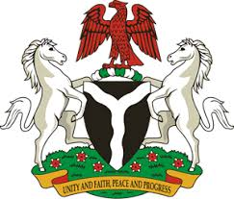
Please check against delivery
HUMAN RIGHTS COUNCIL
40TH SESSION OF THE WORKING GROUP OF THE UPR
REVIEW OF SOUTH SUDAN
31ST JANUARY, 2022

STATEMENT BY NIGERIA
Mr President,
Nigeria warmly welcomes the delegation of the Republic of South Sudan to the presentation of its National Report and applauds the Government for its continued cooperation with human rights mechanisms and commitment to its international and regional human rights obligations.
2. Nigeria takes positive note of the commitment of the Government of South Sudan to the empowerment and protection of the rights of women, girls and children, particularly its efforts in the implementation of treaty obligations, including the Convention on the Elimination of All Forms of Discrimination Against Women (CEDAW), the Convention on the Rights of the Child (CRC) and the Optional Protocol on the Involvement of Children in the Armed Conflict (OPAC).
3. In the spirit of constructive dialogue, Nigeria wishes to recommend the following to the Government of South Sudan:
- The need to intensify efforts to mobilise resources, seek necessary international support and technical assistance to enhance its capacity to promote and protect human rights.
4. Finally, Nigeria wishes South Sudan every success in its review process.
I thank you Mr President.
******

