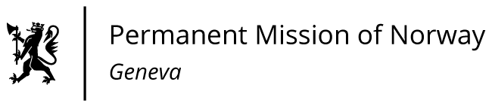

STATEMENT

40th UPR Session of the Human Rights Council

on the human rights situation in Zimbabwe,

as delivered by Ms Jannicke Graatrud,

Minister, Deputy Permanent Representative.

Check against delivery
26 January 2022

Mr. President,

Norway recommends that Zimbabwe

- amends the Private Voluntary Organizations Act after
sector-wide consultations to ensure the right to freedom of association, and to establish an independent regulator that is effective and representative of the PVOs operating in the country;

2) respects the right to freedom of expression and assembly, and ceases the arbitrary arrests and prosecution of journalists, human rights defenders, trade unionists, student activists, opposition candidates and others.

3) adopts legislation to ensure that the right to vote is extended to all citizens, including those imprisoned and the diaspora, and implements recommendations from observer missions to the 2018 Harmonised Elections, including the Motlanthe Commission of Inquiry;

4) abolishes the death penalty in all circumstances and ratifies the Second Optional Protocol to ICCPR;

5) ratifies all core human rights treaties, to safeguard political, civil, economic, social and cultural rights

Thank you.

