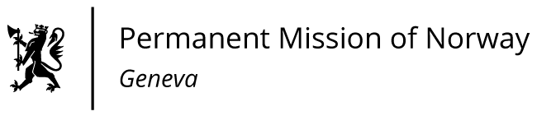

STATEMENT

40th UPR Session of the Human Rights Council

on the human rights situation in Uganda,

as delivered by Ms Jannicke Graatrud,

Minister, Deputy Permanent Representative.

Check against delivery
27 January 2022

Mr. President,

Norway welcomes Uganda’s adoption of the National Action Plan for Business and Human Rights and new membership of EITI.

We remain concerned over the serious human rights violations that occurred in the context of the 2020 elections, and the excessive use of force by police and state security agents.

Norway recommends that Uganda

- takes concrete steps to protect the rights to freedom of expression, association and peaceful assembly, and ensures that human rights defenders, civil society actors, political parties, journalists and the media can operate freely and independently without fear of reprisals;
- protects and promotes the human rights of all persons without discrimination on any grounds, including sexual orientation and gender identity, and decriminalises same-sex conduct;
- provides access to general health care for all, including disability-specific services and programmes;
- ensures adequate access to family planning and acknowledge women’s and girl’s autonomy over their own bodies.

Thank you.

