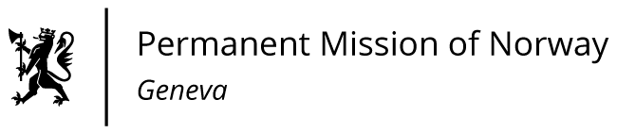

STATEMENT

40th UPR Session of the Human Rights Council
on the human rights situation in in Syria,
statement as delivered by Ambassador Tine Mørch Smith,
Permanent Representative of Norway in Geneva.

Check against delivery
24 January 2022

President,

Norway thanks the delegation of the Syrian Arab Republic for its presentation.

We remain deeply concerned about the many reports of systematic and gross violations of international human rights law and humanitarian law throughout the country.

Norway recommends that the Syrian Arab Republic

1) immediately ends all acts of torture and ill-treatment in line with its obligations under UNCAT, identifies those missing and disappeared, and releases all those arbitrarily or unlawfully detained, including journalists, human rights defenders and political dissidents;

2) allows independent humanitarian organisations full and unhindered access to all places of detention;

3) provides immediate, full, unhindered, and sustained humanitarian access to all people in need in Syria and ensures equal access to food, education and basic health care and services;

4) amends its citizenship laws to ensure Syrian citizenship for children of Syrian women, including children born abroad, in line with the UN Convention on the Rights of the Child;

5) fully cooperates with the United Nations human rights mechanisms.

Thank you.

