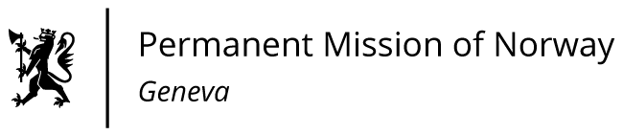

STATEMENT

40th UPR Session of the Human Rights Council

on the human rights situation in Sudan,

as delivered by Ambassador Tine Mørch Smith,
Permanent Representative of Norway in Geneva.

Check against delivery
9 February 2022

President,

Norway regrets and condemns the military take-over on 25 October last year. The coup jeopardises the major improvements in the governance of the country made by the Transitional Government following the 2019 revolution, particularly commitments to peace, democratic transformation, human rights and protection of civilians.

Norway recommends that Sudan
1) revokes the state of emergency, abstains from arbitrary detention, and releases all political prisoners;
2) respects the rights to freedom of expression and assembly, including by allowing peaceful protests, and by ensuring accountability for perpetrators of violence against protesters;

3) cooperates fully with human rights mechanisms, including by issuing a standing invitation to Special Procedures Mandate-holders of the UN Human Rights Council;

4) respects the Sudanese national plan of action for women, peace and security, and implements the provisions of the Convention on the Elimination of All Forms of Discrimination against Women (CEDAW).

Thank you.

