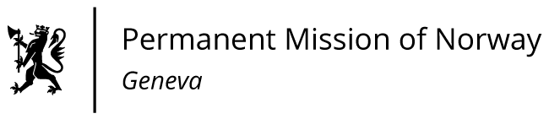

STATEMENT
40th UPR Session of the Human Rights Council
on the human rights situation in the Bolivarian Republic of Venezuela,
as delivered by Ms Anniken Enersen,

Minister-Counsellor, Human Rights.

Check against delivery
25 January 2022

Madam President,

Norway welcomes Venezuela’s participation in the UPR process. We commend the cooperation established with the OHCHR since the last review, as well as the concrete efforts towards conflict resolution through political dialogue.

Norway recommends that Venezuela :

1) continues to search for peaceful and inclusive solutions through negotiations for the benefit of the Venezuelan people;

2) ensures judicial independence, establishes appropriate procedures for the appointment of judges, and ends the use of military tribunals to try civilians;

3) guarantees that NGOs, journalists, trade unionists and human rights defenders can carry out their work without risk of persecution and removes the legal requirement for NGOs to register with the National Office Against Organized Crime and Terrorism Financing;

4) complies with international standards for the use of force and ratifies the Optional Protocol to the Convention against Torture.

Thank you.

