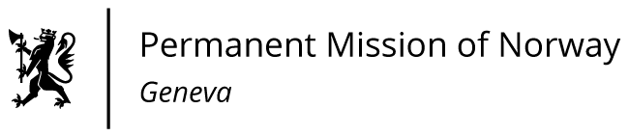

STATEMENT

40th UPR Session of the Human Rights Council

on the human rights situation in Lithuania,

as delivered by Ms Jannicke Graatrud,

Minister, Deputy Permanent Representative.

• 145 [130] ord

• Taletid : 1min 20 sek

• Spilles inn av Jannicke fredag 21 januar

• Norge har taletid som nr.: 75 av 85

Check against delivery
26 January 2022

Madam President,
Norway notes that Lithuania has made important progress towards further ensuring protection of human rights by, among other things, establishing a victim support system, criminalising stalking, and providing additional protection for victims of domestic violence. However, there is a need to strengthen the response to domestic and gender-based violence, including violence against sexual and gender minorities.
Norway recommends that Lithuania
1) implements legal and administrative reforms to ensure non-discrimination of LGBTI people, such as providing legal recognition of same-sex partnerships, legal gender recognition, gender-affirming healthcare for transgender people and combating hate speech and hate crime;
2) follows up the recommendations of the [Council of Europe's Committee for the Prevention of Torture and Inhuman or Degrading Treatment or Punishment] CPT to improve the functioning of the correctional services;
3) ratifies the Istanbul Convention to strengthen its response to domestic and gender-based violence.
Thank you.

