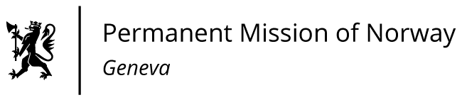

STATEMENT

40th UPR Session of the Human Rights Council

on the human rights situation in Haiti,

as delivered by Ms Anniken Enersen,

Minister-Counsellor, Human Rights.

Check against delivery
31 January 2022

Mr. President,

Norway welcomes the participation of Haiti in the UPR process. We would again like to express our deepest condolences in connection with the assassination of President Moïse and the massive earthquake in August last year. Unfortunately, these tragic events have compounded many of the challenges Haiti already was facing.

We recognise Haiti’s efforts to ratify UN human rights conventions. We note that there are significant challenges to gender equality and women’s rights in Haiti.
Norway recommends that Haiti
1) intensifies its efforts to promote gender equality and combat violence against women, including the rapid adoption and implementation of legislative and regulatory measures to protect the rights of women and girls;

2) takes urgent steps to combat child labour and slavery, and ensures that all children can go to school safely;

3) ensures the rule of law, improved accountability, access to justice and equal treatment before the law;

4) ratifies the Convention against Torture and Other Cruel, Inhuman or Degrading Treatment or Punishment.

I Thank you.

