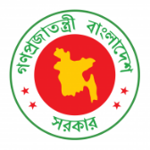
40th Session of UPR Working Group
Statement by Bangladesh in the UPR of Uganda
27 January 2022, 9:00 – 12:30 hrs.

Mr. President,

We recognize the progress in the human rights situation of Uganda since its last UPR. It is appreciative that Uganda has strengthened the legal and institutional frameworks, including by establishing the Parliamentary Committee on Human Rights. Uganda’s achievements in the fight against HIV is notable.

We recommend Uganda to:

- Continue to strengthen the national human rights institution, including through the provision of enhanced funding and resource;

- Continue taking steps to attain universal health care coverage;

- Seek the international community’s support to ensure access to Covid-19 vaccines by all people; and

- Undertake further measures to mitigate the socio-economic implications of Covid-19, with support from the international community.

We wish Uganda success in the review.

I thank you.

****

