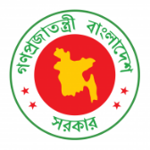
40th Session of UPR Working Group
Statement by Bangladesh in the UPR of Venezuela
25 January 2022, 14:30 – 18:00 hrs.

Mr. President,

Bangladesh welcomes the distinguished delegation of Venezuela and thanks for presenting its national report. We recognize its efforts to combat poverty, strengthen health care and improve access to food.

Bangladesh recommends Venezuela to:

- Continue to strengthen public policies to eradicate extreme poverty, including addressing the challenges posed by the COVID-19 pandemic;

- Continue to develop people’s living conditions, including improved access to electricity, safe drinking water and sanitation; and

- Continue efforts to improve the quality of education at every level.

We wish Venezuela a successful review.

I thank you.

***

