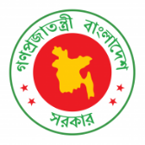
40th Session of UPR Working Group
Statement by Bangladesh in the UPR of South Sudan
31 January 2022, 09:00-12:30 hrs.

Thank you, Mr. President.

We recognize South Sudan's efforts to improve its human rights situation. We note its various challenges, including those caused by the adverse impact of climate change and the COVID-19 pandemic. International communities' continued support is critical for reinforcing South Sudan's efforts to ensure its people's fundamental rights, including food, education and healthcare.

Bangladesh recommends South Sudan to:

One, seek the international community's support to ensure access to Covid-19 vaccines by all people.

Two, seek the international community's support to step up measures to reduce food insecurity and malnutrition.

Three, continue efforts to reduce school dropout and ensure access to basic education by all children.

We wish South Sudan a successful review.

I thank you.
****

