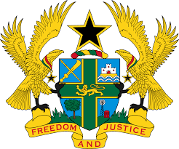

STATEMENT BY GHANA DELIVERED BY AKOSUA D. OKYERE BADOO,
CHARGÉ D'AFFAIRES/ DEPUTY PERMANENT REPRESENTATIVE,
MONDAY, 31ST JANUARY, 2022

REVIEW OF SOUTH SUDAN

Thank you, Mr. President,
Ghana welcomes the participation by the delegation of South Sudan to the UPR process.
We commend South Sudan for progress made since its previous UPR and the various efforts made to implement the Revitalised Agreement of the Resolution of Conflict in South Sudan (R-ARCSS). We further welcome the ratification of various regional and international human rights instruments which promotes the child rights and also commend the efforts made to protect women rights in the country.
We, however, remain concerned with reports on violence, including the harassment, raping and killing of civilians and humanitarian aid workers.
Ghana makes the following recommendations:
- Continue efforts to strengthen and implement outstanding commitments to the Revitalised Agreement;
- Continue to reinforce relevant measures to promote and protect the rights to freedom of expression as well as rights to peaceful assembly and association ;
- Ensure proper investigation into allegations of violations of
international humanitarian and human rights law and bring the perpetrators to justice and;
- Continue its efforts towards peace and national reconciliation.

We wish South Sudan a successful review outcome.
I thank you.

