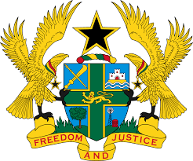
STATEMENT BY GHANA DELIVERED BY AKOSUA D. OKYERE BADOO,
CHARGÉ D'AFFAIRES/ DEPUTY PERMANENT REPRESENTATIVE,
WEDNESDAY, 26TH JANUARY, 2022

REVIEW OF ZIMBABWE

Thank you, Mr. President
Ghana warmly welcomes the delegation of Zimbabwe to the UPR Working Group.
My delegation commends the government for the commitment and considerable progress in promoting, protecting and respecting human rights in the country through the adoption of the five-year National Anti-Corruption Strategy, National Health Strategy (2016-2020) and a robust HIV response strategy.

We also take note with admiration strategies adopted to combat gender based violence in the country.

To further strengthen human rights promotion and protection in Zimbabwe my delegation wishes to make the following recommendations:

- Intensify its efforts to ratify outstanding International treaties and protocols, including the United Nations Convention Against Torture (UNCAT) and its Optional Protocol;

- Continue to strengthen efforts in the implementation of laws and policies on freedom of expression and assembly and lastly;

- Step up its efforts to ensure more effective enforcement of policies and legislation to address discrimination against and marginalization of women.

We wish Zimbabwe a successful review.

I thank you.

