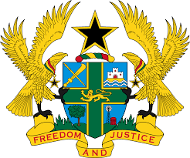

STATEMENT BY GHANA DELIVERED BY AKOSUA D. OKYERE BADOO,
CHARGÉ D'AFFAIRES/ DEPUTY PERMANENT REPRESENTATIVE,
THURSDAY, 27TH JANUARY, 2022

REVIEW OF UGANDA

Thank you, Mr. President,
Ghana warmly welcomes the delegation of Uganda to the UPR Working Group.
We acknowledge the significant progress made by Uganda in enhancing its legal framework for the promotion and protection of human rights through the development and implementation of policies aimed at achieving the UN Sustainable Development Goals (SDGs).
My delegation also commends the implementation of Second National Plan of Action for the Prevention of Trafficking in Persons (2019-2024) and National Gender in Education Policy (2016).
Ghana makes the following recommendations:
- Continue to reinforce measures that guarantee the rights of citizens to peaceful demonstration and freedom of expression;

- Continue to take further measures to enhance health-care
services, especially the vulnerable group and people living in the rural areas and lastly,
- Intensify its efforts to accede to outstanding international legal instruments to which Uganda is not yet a party, including the Optional Protocol to the Convention on Torture ( OPCAT);

We wish Uganda a successful review outcome.

I thank you.

