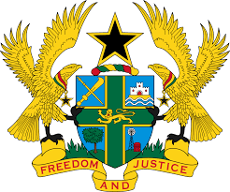

STATEMENT BY GHANA DELIVERED BY AKOSUA D. OKYERE BADOO,
CHARGÉ D'AFFAIRES/ DEPUTY PERMANENT REPRESENTATIVE,
MONDAY, 24TH JANUARY, 2022

REVIEW OF TOGO

Thank you, Mr. President
Ghana welcomes the participation by the delegation of Togo to the UPR process.
We welcome the progress made since its previous UPR, in particularly measures to improve and promote human rights in the country. This includes measures made to strengthen national human rights institutions in the country, improve quality of education as well as reforms to improve the judicial service.
Ghana makes the following recommendations:
- Accede to those international legal instruments to which Togo is not yet a party, including the Optional Protocol to the Convention on the Elimination of All Forms of Discrimination against Women;
- Establish and effectively support a sustainable system of social accountability for public health services to ensure quality preventive and curative care for all people and lastly;
- Intensify efforts to investigates all acts of allegations of torture and ill-treatment and bring perpetrators to justice.
We wish Togo a successful review.

I thank you.

