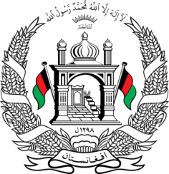
Permanent Mission of Islamic Republic of Afghanistan
40th Session of the UPR Working Group
Statement at the Third Cycle UPR of Timor-Leste
27 January 2022 14:30 – 18:00
Thank you, _____
Afghanistan welcomes the distinguished delegation of Timor-Leste and thanks them for their detailed presentation of their national report. We commend the country’s efforts towards equal representation and diversity of thought. We also commend Timor-Leste’s cooperation with UN human rights mechanisms in submitting reports to several monitoring mechanisms since the second cycle.
We remain concerned about the lack of a general legal framework on children’s rights.
In the spirit of constructive engagement, we hope to make the following recommendations:
- Enact a comprehensive legislation on children’s rights;
- Ratify the Convention on the Rights of Persons with Disabilities;
- And ensure compliance with non-refoulement principles by ensuring that all asylum seekers are given access to fair and efficient asylum procedures, including access to relevant information, interpretation, and legal services.
We wish Timor-Leste every success in the UPR process.
I thank you, ____

