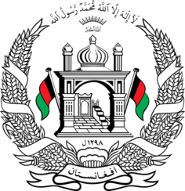
Permanent Mission of Islamic Republic of Afghanistan
40th Session of the UPR Working Group
Statement at the Third Cycle UPR of Sudan
1 February 2022 9:00 – 12:30
Thank you, _____
Afghanistan welcomes the distinguished delegation of Sudan and thanks them for their detailed presentation of their national report. Afghanistan notes with appreciation that since the last review cycle, Sudan has ratified numerous international instruments, including the Convention Against Torture. We remain concerned about Sudan’s failure on the implementation of some international human rights obligations, including on the rights of refugees and asylum seekers.
In the spirit of constructive engagement, we wish to make the following recommendations:
- Adopt a comprehensive anti-discrimination and equalities law banning discrimination based on grounds such as race, color, sex, language, religion, political or other opinion, national or social origins, age, and disability.
- Ensure the proper treatment of refugees and asylum seekers through the application of the UN Refugee Convention and the Asylum Regulations Act.
Finally, Afghanistan wishes Sudan every success in the UPR process.
I thank you, ____

