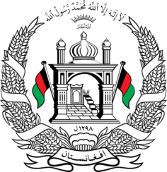
Permanent Mission of Islamic Republic of Afghanistan
40th Session of the UPR Working Group
Statement at the Third Cycle UPR of Lithuania
26 January 2022 14:30 – 18:00
Thank you, _____
Afghanistan welcomes the distinguished delegation of Lithuania to this UPR working group session. We express our appreciation for their engagement with the UPR and for their efforts towards fulfillment of their human rights obligations since the previous cycle.
While we commend the strides Lithuania has made towards being a more inclusive society, we remain concerned about the denial of access to asylum procedures, including the services of lawyers, as well as the rights of women. In the spirit of constructive engagement, we wish to make the following recommendations:
- Ensure that all applications for international protection are promptly received, registered, and referred to the asylum authority, and that it effectively investigates all allegations of denials of entry and access to asylum procedures for persons seeking international protections;
- Adopt temporary special measures to increase the participation of women, in particular rural women, women belonging to ethnic minority groups and women with disabilities, in political and public life.
We wish Lithuania every success in the UPR process.
I thank you, ____

