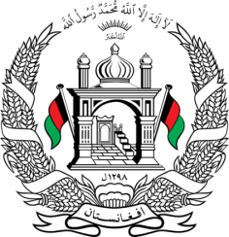
Permanent Mission of Islamic Republic of Afghanistan
40th Session of the UPR Working Group
Statement at the Third Cycle UPR of Iceland
25 January 2022 9:00 – 12:30
Thank you, Madame President,
Afghanistan welcomes the distinguished delegation of Iceland and thanks them for their detailed presentation of their national report. Iceland should be commended on their strides towards equality, justice, and perhaps most importantly, accountability. We also commend Iceland for the ratification on the Convention for the Rights of Persons with Disabilities.
We remain concerned about the high percentage of migrant children dropping out of school after finishing compulsory education. In the spirit of constructive engagement, we wish to make the following recommendations:
- Ensure that all refugees and asylum seeker’s children enjoy the right to education, particularly secondary education:
- Ensure that non-refoulement principles are secured in law and in practice.
Finally, we wish Iceland every success in the UPR process.
I thank you, ____

