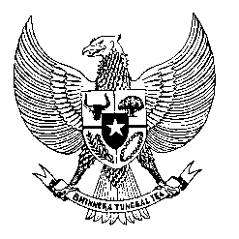

Permanent Mission
of the Republic of Indonesia to the UN, WTO,
and Other International Organizations
in Geneva

Statement
by the Delegation of the Republic of Indonesia
at the 40th Session of the UPR Working Group
Consideration of the UPR Report of Zimbabwe
26 January 2021

President,

Indonesia thanks the delegation of Zimbabwe for their report.

Indonesia commends Zimbabwe’s efforts in promoting the right to education, particularly by guaranteeing education as a basic human right through the amendment of the Education Act, as well as its efforts in handling the current pandemic.

To further improve progress in the promotion and protection of human rights in Zimbabwe, Indonesia offers the following recommendations:

- Consider ratifying the UN Convention Against Torture and Other Cruel, Inhuman, or Degrading Treatment or Punishment;
- Take further measures in combating corruption through training and awareness raising programs on the economic and social costs of corruption; and
- Enhance effort to widen access to healthcare to its citizen, including in the handling of the pandemic, involving also possible bilateral and international cooperation.
Indonesia wishes the delegation of Zimbabwe a successful review.

I thank you.

(Max: 1:05)

