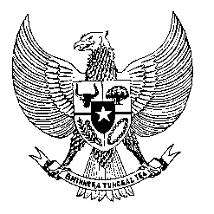

Permanent Mission
of the Republic of Indonesia to the UN, WTO,
and Other International Organizations
in Geneva

Statement
by the Delegation of the Republic of Indonesia
at the 40th Session of the UPR Working Group
Consideration of the UPR Report of Togo
24 January 2021

President,

Indonesia thanks the delegation of Togo for their report.

Indonesia welcomes the progress made by Togo in strengthening its human rights legislation since its last UPR, in particular its ratification of the International Convention on the Protection of Migrant Workers and Members of their Families.

To further improve progress in the promotion and protection of human rights in Togo Indonesia offers the following recommendations:

- Take further measures in combating corruption through training and awareness raising programs on the economic and social costs of corruption.
- Continue efforts in improving prison conditions and the treatment of people in detention, involving also possible bilateral and international cooperation; and
- Consider developing a national action plan on human rights, including in the business sector;
Indonesia wishes the delegation of Togo a successful review.

I thank you.

(Max: 1:10)

