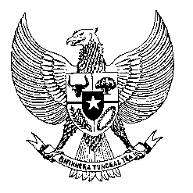

Permanent Mission
of the Republic of Indonesia to the UN, WTO,
and Other International Organizations
in Geneva

STATEMENT BY THE DELEGATION OF THE REPUBLIC OF INDONESIA
AT THE 40th SESSION OF THE UPR WORKING GROUP
CONSIDERATION OF THE UPR REPORT OF TIMOR LESTE

Mr. President,

My delegation welcomes the Delegation of Timor-Leste and appreciate the presentation.

We also appreciate efforts to advance gender equality in the government and parliament of Timor-Leste and note the progress in several areas of human rights in Timor-Leste. Indonesia stands ready to continue our support for the advancement of human rights respect in Timor-Leste.

With the constructive spirit, Indonesia recommends:

- Step up efforts to improve national healthcare services and infrastructure, and capacities of healthcare staff, through bilateral and regional cooperation, to ensure access to healthcare and reduce stunting particularly in rural areas.
- Strengthen efforts to eliminate domestic violence through legislation and increase awareness raising programs.
- Continue to improve capacities of law enforcement officers and the judiciary to promote access to justice for all.

We wish the Government of Timor-Leste every success in their review.

Thank you.
Time 1:30
15th speaker
190 words

