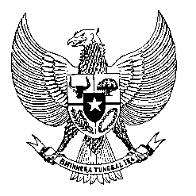

Permanent Mission
of the Republic of Indonesia to the UN, WTO,
and Other International Organizations
in Geneva

Statement
by the Delegation of the Republic of Indonesia
at the 40th Session of the UPR Working Group
Consideration of the UPR Report of Sudan
1 Februari 2021

President,

Indonesia thanks the delegation of Sudan for their report.

Indonesia continues to offer our sincere hope that the evolving political situation in Sudan can be resolved peacefully, through an inclusive and democratic national dialogue.

Furthermore, Indonesia welcomes Sudan’s ratification of the UNCAT in 2021.

To further improve progress in the promotion and protection of human rights in Sudan, Indonesia offers the following recommendations:

- Take all necessary steps to safeguard democratic principles based on the principles of good governance and respect for human rights;
- Continue to enhance the promotion interfaith dialogue and religious tolerance; and
- Take further efforts in improving human rights respect, through education and training program on human rights to State’s apparatus, involving also possible bilateral and international cooperation.
Indonesia wishes the delegation of Sudan a successful review.

I thank you.

(Max: 1:05)

