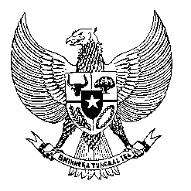

Permanent Mission
of the Republic of Indonesia to the UN, WTO,
and Other International Organizations
in Geneva

STATEMENT BY THE DELEGATION OF THE REPUBLIC OF INDONESIA
AT THE 40th SESSION OF THE UPR WORKING GROUP
CONSIDERATION OF THE UPR REPORT OF VENEZUELA
25 January 2022

Thank you, Mr. President,

My Delegation thank the Delegation of Venezuela of their presentation.

We appreciate Venezuela cooperation with UN agencies in implementing the national human rights action plan.

Indonesia recommends the following:

- Take concrete and immediate action to ensure the availability of essential needs including food, electricity, clean water and medicine.

- Take all necessary measures to ensure fulfilment of the right to education for all children.

- Promote democracy through strengthening of democratic institutions and citizen’s right to participate in political and public affairs, including with possible bilateral cooperation with friendly countries.

We wish Venezuela success in this review and its full implementation.

Thank you.
Time 55
80th speaker
111 words

