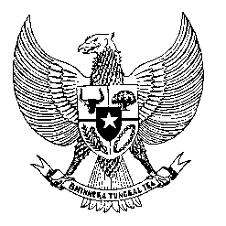

Permanent Mission
of the Republic of Indonesia to the UN, WTO,
and Other International Organizations
in Geneva

STATEMENT BY THE DELEGATION OF THE REPUBLIC OF INDONESIA
AT THE 40th SESSION OF THE UPR WORKING GROUP
CONSIDERATION OF THE UPR REPORT OF LITHUANIA

Thank you, Mr. President,

My Delegation thank the Delegation of Lithuania of their presentation.

We appreciate the progress made since Lithuania’s second review including the strengthening of NHRI which have acquired A status and strengthening of legislation to provide better protection for children.

For this cycle, Indonesia recommends as follows:

- Continue to fully implement the Action Plan on the Promotion of Non-discrimination with clear strategic goals, specific measures, and adequate financing.

- Take all necessary measures to combat trafficking in persons and provide adequate human and financial resources to support victims of trafficking.

- Effectively implement action plans and measures aimed at strengthening social integration of national minorities and migrants, as well as equality
on socio-economic of its people.

We wish the Delegation of Lithuania success in this review and its implementation.

Thank you.
Time 1:20
54th speaker
124 words

