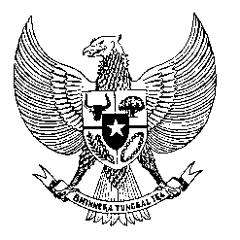

Permanent Mission
of the Republic of Indonesia to the UN, WTO,
and Other International Organizations
in Geneva

STATEMENT BY THE DELEGATION OF THE REPUBLIC OF INDONESIA
AT THE 40th SESSION OF THE UPR WORKING GROUP
CONSIDERATION OF THE UPR REPORT OF HAITI

Thank you, Mr. President,

My delegation thanks the Delegation of Haiti for their presentation.

While taking note the progress in several areas of human rights in Haiti my Delegation is of the view that further effort to address the instability and security problems in the country should be taken. Law enforcement and anti-corruption should be further improved, including through support from international community and related UN mechanism.

Therefore, Indonesia wishes to recommend the following:

1. Take necessary measures to improve the capacity and respect for human rights by the law enforcement and the judiciary including through training on human rights.

2. Take all necessary measures to promote transparency and increase efforts to combat corruption.

3. Continue to implement programs and policies to improve socio-economic condition and welfare of the Haitian people, particularly to empower women and children, involving possible bilateral and international cooperation.

We wish the Government of Haiti a successful review.

Thank you.

Time 1:20
5th speaker
154 words

