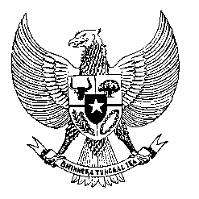

Permanent Mission
of the Republic of Indonesia to the UN, WTO,
and Other International Organizations
in Geneva

Statement
by the Delegation of the Republic of Indonesia
at the 40th Session of the UPR Working Group
Consideration of the UPR Report of Iceland
25 January 2021

President,

Indonesia thanks the delegation of Iceland for their report.

Indonesia commends Iceland’s efforts in countering discrimination, racial prejudice, and hate speech, since its last review, as well as its efforts in combating disinformation and misinformation related to pandemic.

To further improve human rights in Iceland, Indonesia offers the following recommendations:

- Take further steps towards establishing an NHRI that is in full compliance with the Paris Principles, with possible bilateral and international collaboration;
- Consider acceding to the International Convention on the Protection of the Rights of All Migrant Workers and Members of their Families; and
- Endorse and implement the United Nations Compact for Safe, Orderly and Regular Migration.

Indonesia wishes the delegation of Iceland a successful review.

I thank you.

(Max: 1:15)

