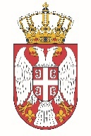

Permanent Mission of the Republic of Serbia to the United Nations Office in Geneva

Working Group for UPR
Interactive Dialogue on Report of Zimbabwe
January 2022

The Republic of Serbia welcomes the delegation of Zimbabwe at the UPR’s Session and thanks for presenting the National Report.

Zimbabwe has shown a high level of dedicated approach to the UPR process, and we commend all the measures its authorities has taken in order to respond to the UPR recommendations.

We would like to recommend to Zimbabwe protect the livelihoods of rural women and support women farmers with incentives, access to credit and other productive sources

Serbia wishes Zimbabwe a fruitful review process.

