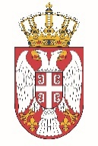

Permanent Mission of the Republic of Serbia to the United Nations Office in Geneva

Working Group for UPR
Interactive Dialogue on Report of Uganda
January 2022

The Republic of Serbia welcomes the delegation of Uganda at the UPR’s Session and thanks for presenting the National Report.

Uganda has shown a high level of dedicated approach to the UPR process, and we commend all the measures its authorities has taken in order to respond to the UPR recommendations.

We would like to recommend to Uganda to strengthen its efforts to ensure the effective elimination of child labour, especially in hazardous work

Serbia wishes Uganda a fruitful review process.

