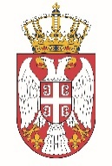

Permanent Mission of the Republic of Serbia to the United Nations Office in Geneva

Working Group for UPR
Interactive Dialogue on Report of Togo
January 2022

The Republic of Serbia welcomes the delegation of Togo at the UPR’s Session and thanks for presenting the National Report.

Ireland has shown a high level of dedicated approach to the UPR process, and we commend all the measures its authorities has taken in order to respond to the UPR recommendations.

We would like to recommend to Togo to implement an effective plan to reduce maternal and infant mortality rates, ensure that all children are duly registered at birth and have equal access to education, health care and other social services, including those who are unregistered or lack birth certificates
Serbia wishes Togo a fruitful review process.

