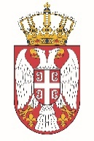

Permanent Mission of the Republic of Serbia to the United Nations Office in Geneva

Working Group for UPR
Interactive Dialogue on Report of Timor Leste
January 2022

The Republic of Serbia welcomes the delegation of Timor Leste at the UPR’s Session and thanks for presenting the National Report.

Timor Leste has shown a high level of dedicated approach to the UPR process, and we commend all the measures its authorities has taken in order to respond to the UPR recommendations.

We would like to recommend to Timor Leste to bring birth registration services closer to beneficiaries, especially in rural areas, while making the administrative process more effective and less costly

Serbia wishes Timor Leste a fruitful review process.

