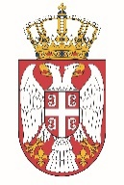

Permanent Mission of the Republic of Serbia to the United Nations Office in Geneva

Working Group for UPR
Interactive Dialogue on Report of Sudan
February 2022

The Republic of Serbia welcomes the delegation of Sudan and thanks the head of delegation for presenting the UPR National Report.
Serbia appreciates all the efforts Sudan has invested within the UPR process in the previous period that are of the benefit for its citizens. We welcome in particular the measures Sudanese authorities has taken in improving the health situation in the country by adopting and implementing the four-year strategic plan 2021–2024.
We would like to recommend to Sudan the following:
- to strive to implement the national poverty reduction strategy even more effectively in order to eliminate its root causes.
- to step up efforts to combat all forms of discrimination against women.
Serbia wishes Sudan a fruitful review process.

