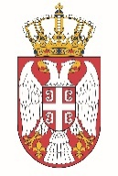

Permanent Mission of the Republic of Serbia to the United Nations Office in Geneva

Working Group for UPR
Interactive Dialogue on Report of Moldova
February 2022

The Republic of Serbia welcomes the delegation of Moldova at the UPR’s Session and thanks for presenting the National Report.

Moldova has shown a high level of dedicated approach to the UPR process, and we commend all the measures its authorities has taken in order to respond to the UPR recommendations.

We would like to recommend to Moldova to strengthen the role and independence of the Office of the Ombudsman and the Equality Council by, inter alia, ensuring that they could provide effective remedies and guaranteeing their financial independence with sufficient budgetary and human resources for their adequate and effective functioning;

Serbia wishes Moldova a fruitful review process.

