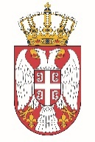

Permanent Mission of the Republic of Serbia to the United Nations Office in Geneva

Working Group for UPR
Interactive Dialogue on Report of South Sudan
February 2022

The Republic of Serbia welcomes the delegation of South Sudan at the UPR’s Session and thanks for presenting the National Report.

South Sudan has shown a high level of dedicated approach to the UPR process, and we commend all the measures its authorities has taken in order to respond to the UPR recommendations.

We would like to recommend to South Sudan to substantially increasing budgetary allocations for the public health sector; strengthening the capacities of public health facilities and health workers;
Serbia wishes South Sudan a fruitful review process.

