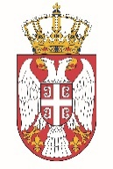

Permanent Mission of the Republic of Serbia to the United Nations Office in Geneva

Working Group for UPR
Interactive Dialogue on Report of Lithuania
January 2022

The Republic of Serbia welcomes the delegation of Lithuania at the UPR’s Session and thanks for presenting the National Report.

Lithuania has shown a high level of dedicated approach to the UPR process, and we commend all the measures its authorities has taken in order to respond to the UPR recommendations.

We would like to recommend to Lithuania the following:
- to allocate sufficient funding to the office Seimas Ombudsmen so that it could effectively and independently fulfil its mandate, including in the new areas of competence
- accelerate the drafting and adoption of a comprehensive law on national minorities and ensure that representatives of the different national minorities were consulted in the course of the drafting process

Serbia wishes Lithuania a fruitful review process.

