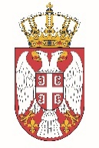

Permanent Mission of the Republic of Serbia to the United Nations Office in Geneva

Working Group for UPR
Interactive Dialogue on Report of Haiti
February 2022

The Republic of Serbia welcomes the delegation of Haiti at the UPR’s Session and thanks for presenting the National Report.

Haiti has shown a high level of dedicated approach to the UPR process, and we commend all the measures its authorities has taken in order to respond to the UPR recommendations.

We would like to recommend to Haiti to integrate the rights of women and girls with disabilities into the gender equality legislation, as well as into laws and policies on disability, and conduct public awareness campaigns to modify stereotypes, prejudices and myths about women and girls with disabilities.

Serbia wishes Haiti a fruitful review process.

