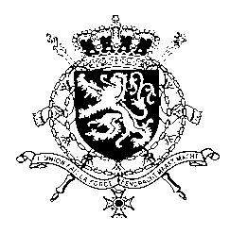
Représentation permanente de la Belgique auprès des Nations Unies et auprès des institutions spécialisées à Genève

WG UPR 40 – Uganda
Belgian Intervention
27 January 2022

Mr. President,

We welcome the robust preparations made by the government of Uganda in the exercise of this UPR and note the progress achieved since the previous review. Nevertheless, Belgium is of the view that respect for human rights needs further attention and recommends to:

R1. Thoroughly, transparently, independently and effectively investigate allegations of attacks against human rights defenders, civil society actors, bloggers, journalists, and others before, during and after the last presidential elections and hold those responsible to account
R2. Take all appropriate measures, including the allocation of an increased share of the government budget to the education sector, to mitigate the impact of the COVID-19 pandemic and accelerate progress towards SDG4, ensuring inclusive and equitable quality education

R3. Strengthen sexual and gender-based violence referral systems to help support victims, in particular with their access to medical, economic, legal and psycho-social services.

Thank you, Mr. President.

