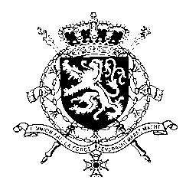
Représentation permanente de la Belgique auprès des Nations Unies et auprès des institutions spécialisées à Genève

WG UPR 40 – Sudan
Belgian Intervention
1 February 2022

Mr. President,

Belgium thanks the delegation of Sudan for its presentation. We express deep concern about the suspension of key articles of the Constitutional Document and the governing bodies following the events on 25 October 2021 and by the continued use of lethal violence during protests.

In the context of this UPR, Belgium would like to make following recommendations:

R1. Consider ratifying the Rome Statute of the International Criminal Court, and provide unconditional cooperation and access to areas of concern for ICC investigators

R2. Ensure continued consultation with women’s rights groups and include a gender perspective throughout the implementation of the Juba peace agreement, including in security and military sector reform at all decision-making levels

R3. Increase efforts towards ensuring accountability for grave violations against children by bringing perpetrators to justice and by providing remedies to victims

Thank you, Mr. President.

