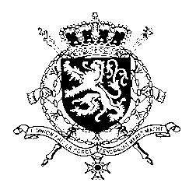
Représentation permanente de la Belgique auprès des Nations Unies et auprès des institutions spécialisées à Genève

WG UPR 40 – Republic of Moldova
Belgian intervention
28th of January 2022

Mr. President,

Belgium welcomes the progress and achievements made by the Republic of Moldova since its previous UPR, such as the ratification of the Council of Europe Convention on Preventing and Combating Violence against Women and Domestic Violence. Notwithstanding these achievements, there is still room for progress.

Belgium therefore recommends the government of the Republic of Moldova to:

R1. Provide holistic specialist support services for women experiencing violence, including social assistance and economic empowerment, in line with the Council of Europe Convention on Preventing and Combatting Violence against Women and Domestic Violence

R2. Strengthen the capacities of the People’s Advocate Institution in order to monitor and protect human rights in the Transnistrian region

R3. Intensify efforts to enable the media to work without undue interference or intimidation, including when investigating corruption cases and reporting on demonstrations.

Thank you, Mr. President.

