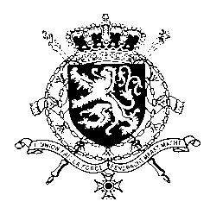
Représentation permanente de la Belgique auprès des Nations Unies et auprès des institutions spécialisées à Genève

WG UPR 40 – South Sudan
Belgian Intervention
31 January 2022

Mr. President,

Belgium appreciates South Sudan’s engagement with the UPR mechanism and encourages the government to redouble its efforts to ensure respect for human rights. Belgium recommends to:

R1. Fully implement the legal provisions relating to gender equality and sexual and gender-based violence, in order to enhance the protection of women and girls against discrimination and gender-based violence

R2. Adopt the Draft Statute of the Hybrid Court for South Sudan and ensure that the Court is established and becomes rapidly operational, and furthermore implement all other transitional justice provisions of the peace agreement

R3. Take necessary steps to stop harassment, threatening, arbitrary arrest and detention of human rights defenders, journalists and critics of the government and government officials, and ensure that all government institutions respect, promote and protect the rights to privacy, to freedom of expression and to peaceful assembly.

Thank you, Mr. President.

