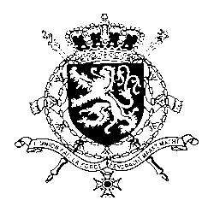
Représentation permanente de la Belgique auprès des Nations Unies et auprès des institutions spécialisées à Genève

WG UPR 40 – Iceland
Belgian intervention
25th of January 2022

Mr. President,

Belgium congratulates the government of Iceland for the achievements and progress made since its previous UPR.

In order to complement the efforts made, Belgium recommends the government of Iceland to:

R1. Consider ratifying the Convention for the Protection of All Persons from Enforced Disappearance (CED) as well as the Optional Protocol to the Convention on the Rights of the Child on a communication procedure (CRC-OP-IC)

R2. In the fight against violence against women, continue to provide adequate preventive measures as well as support and counseling; and continue to provide access to justice for victims, including foreign women and women from minority backgrounds

Finally, Belgium congratulates Iceland for the creation of integrated support services for children, putting the child at the center, and recommends the government:

R3. To ensure that all competent services continue participating in its implementation and that lessons learned be shared.

Thank you, Mr. President.

