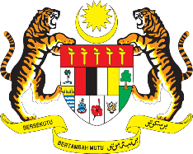

STATEMENT BY MALAYSIA
REVIEW OF ZIMBABWE
40TH SESSION OF THE UPR WORKING GROUP
24 JANUARY – 4 FEBRUARY 2022

Malaysia thanks Zimbabwe for its comprehensive presentation of its national report.

- Malaysia is pleased to note various legislative and policy frameworks that have been developed following Zimbabwe’s Second UPR. We commend the launch of its National Disability Policy to promote and protect the rights of persons with disabilities.

- In the spirit of constructive engagement, Malaysia proposes the following recommendations for the consideration of Zimbabwe:

  - Strengthen efforts to improve access to health-care facilities and medical assistance in order to address the overall mortality rate; and

  - Take steps to improve access to education during the pandemic period, including by providing training for teachers and lecturers on using e-learning platforms.

- We wish Zimbabwe a successful review.

Thank you.

26 JANUARY 2022
GENEVA

