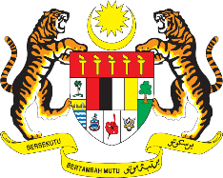

STATEMENT BY MALAYSIA
REVIEW OF UGANDA
40TH SESSION OF THE UPR WORKING GROUP
24 JANUARY – 4 FEBRUARY 2022

Malaysia thanks Uganda for its national report.

- Malaysia welcomes Uganda’s consultative approach in its UPR undertakings. We encourage Uganda to continue social and economic reforms to protect the welfare, wellbeing and human rights of all particularly the most vulnerable. We further encourage the Government to continue upholding its international obligations including those relating to human rights and Sustainable Development Goals. We commend the recent enactment of Mental Health Act and Persons with Disabilities Act in 2020 and look forward to their effective implementation.

- In the spirit of constructive engagement, Malaysia proposes the following recommendations for the consideration of Uganda:

3.1. Continue taking steps to reduce maternal mortality rate through high quality, robust and comprehensive measures; and
3.2. Ensure adequate support and resources to Uganda’s national council for persons with disabilities to enable the institution to fulfil its mandate effectively.

- Malaysia wishes Uganda a successful review.

Thank you.

27 JANUARY 2022
GENEVA

