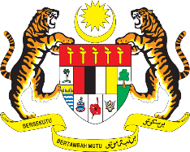

STATEMENT BY MALAYSIA
REVIEW OF TOGO
40TH SESSION OF THE UPR WORKING GROUP
24 JANUARY – 4 FEBRUARY 2022

Malaysia thanks Togo for its national report.

- Malaysia welcomes Togo’s commitment to the UPR, and various advancements made since its last review. Among others, we commend Togo for taking steps to increase access to education, improve the quality of teaching and training and to enhance the performance of the education system. We also note the steps taken to combat trafficking in children.

- Togo’s efforts to tackle maternal and neonatal deaths are encouraging. In this connection, we welcome national programmes to provide support to pregnant women and newborns and access to quality essential health-care services.

- In the spirit of constructive engagement, Malaysia proposes the following recommendations for the consideration of Togo:

4.1. Continue taking concrete measures to promote the rights of children including by addressing child labour;
4.2. Tackle disparity between the enrolment rates for girls and boys in secondary and higher education through inclusive and robust measures; and
4.3. Strengthen measures towards gender equality.

- Malaysia wishes Togo every success in its UPR undertakings.

Thank you.

24 JANUARY 2022
GENEVA

