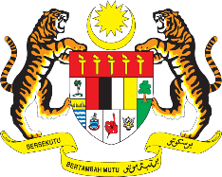

STATEMENT BY MALAYSIA
REVIEW OF TIMOR-LESTE
40TH SESSION OF THE UPR WORKING GROUP
24 JANUARY – 4 FEBRUARY 2022

Malaysia thanks Timor-Leste for the comprehensive presentation of its national report.

- Malaysia welcomes the positive steps taken by Timor-Leste in implementing recommendations from its previous UPR cycle. We also commend the implementation of the Government’s various policies of social assistance for persons with disabilities. We encourage Timor-Leste to continue its efforts to ensure effective implementation, including prioritising the ratification of the Convention on the Rights of Persons with Disabilities.

- In the spirit of constructive engagement, Malaysia proposes the following recommendations for the consideration of Timor-Leste:

  - Continue efforts to address violence against women and girls, including by ensuring access to justice through judicial and institutional training on gender-based violence awareness and responses;

  - Consider adopting an integrated National Human Rights Action Plan for coordination of the implementation of its various thematic National Action Plans in the country; and

  - Taking steps in providing capacity-building programmes including targeted training for law enforcement officials.

- We wish Timor-Leste a successful review.

Thank you.

27 JANUARY 2022
GENEVA

