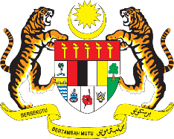

STATEMENT BY MALAYSIA
REVIEW OF SYRIA
40TH SESSION OF THE UPR WORKING GROUP
24 JANUARY – 4 FEBRUARY 2022

Malaysia thanks Syria for its national report.

- Malaysia welcomes Syria’s engagement with the Human Rights mechanisms including the UPR. Malaysia encourages cooperation, constructive dialogue and international efforts to reach a peaceful and comprehensive settlement to the crisis in the Syrian Arab Republic. In this connection, Malaysia iterates that all parties must take necessary measures to protect the civilians. We further encourage Syria continue engaging all international bodies in ensuring humanitarian assistance to those affected.

- In the spirit of constructive engagement within the UPR framework, Malaysia proposes the following recommendations for the consideration of Syria:

3.1. Continue education and awareness-raising on international human rights treaties to which it is a party;
3.2 Implement policies aimed at ensuring the participation of persons with disabilities in public life, including by expanding the base of international partnerships; and
3.3. Further strengthen the bilateral and international cooperation in the field of poverty reduction.

- Malaysia wishes Syria every success in its UPR undertakings.

Thank you.

24 JANUARY 2022
GENEVA

