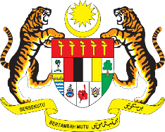

STATEMENT BY MALAYSIA
REVIEW OF SUDAN
40TH SESSION OF THE UPR WORKING GROUP
24 JANUARY – 4 FEBRUARY 2022

Malaysia thanks Sudan for its national report.

- Malaysia welcomes Sudan’s commitment to the UPR. In the spirit of constructive engagement within the UPR framework, Malaysia proposes the following recommendations for the consideration of Sudan:

2.1. Ratify United Nations Convention on the Elimination of All Forms of Discrimination against Women;
2.2. Empower and promote the economic inclusion of all persons, irrespective of their disability status; and
2.3. Prohibit discriminatory, ill-treatment or criminal offences committed by members of the law enforcement agencies against civilians.

- Malaysia hopes that long lasting peace and sustainable stability will be achieved in Sudan.

- We wish Sudan every success in its UPR undertakings.

Thank you.

28 JANUARY 2022
GENEVA

